# Prototype

## Justify the areas of the problem to be included in the prototype system.

The new RSPBANI application has many key areas that I have been asked to development, which are as followed:

* Band management
* Admin management
* Judge management
* Booking transport (email)
* Competitions
* Results

The aim of my prototype is to give the association a quick initial feel for the solution I will be developing. My prototype will give me flexibility in my design, as I am able to react to the customers opinions and reflect my solution to the requirements of the customer. This will allow me change how I will continue to develop my solution if needs be.

From my investigation phase, it was clear to me that there would be no point in implementing the Competitions and Results functionality until I had got the basic functionality of the band, admin and judge management sections. If I were to make the competition area first, I would not be able to enter any bands for any of the competitions which therefore also makes the implementation of the results unnecessary. I would not be able to test this feature as I went along as there would be no bands to test it with. For this reason, I decided to begin with the management side of the system. I have created all basic functionality around the creation of all users (bands, judges and admins) and allowed them to log into the system which brings additional functionality that depends on their access rights attached to their account.

I have developed most of the features that are available to bands once they log in. I have decided to not develop the transfer member feature has this requires the same skills as other features implemented and is not integral to the main objectives of the system.

I have decided to show how the admin is able to override the band functionality with one of the features available to each of the bands - if there is ever an issue and a band cannot do it themselves for whatever reason. I have been able to do this by adding another screen that asks the admin to select the band they wish to edit the details for before being shown exactly the same screen the band would have seen if they were logged in.

In my prototype, I have implemented the ability for admins to be able to register more accounts. I have created three simple forms with the required fields that I was given during my document analysis part of the investigation. Alongside this I have started to develop the functionality for entering competitions. An Admin is able to create a competition, after which bands can then enter it, once they log on. The admin then has the ability to make the draw for the competition and the judge can enter their results during the competition. They must go through a selection of list boxes so that they enter their result about the correct band and section of the band. This is however not fully developed but I have started it to show where I am going with it.

I have not implemented any validation into the prototype as it would make the quick development very tedious and is not necessary as it doesn’t affect the functionality, this however means my prototype is not robust, but this robustness will come in the software development once I have all the functionality implemented and working correctly.

I wanted to design the UI in my prototype completely as I felt this was key to ensuring the client was happy with the prototype and overall appearance of their solution. I have kept my UI design consistent between screens, as this is required in industry level solutions for a successful solution which the client is happy with.

## Produce a range of screens and outputs for the prototype solution.

## Create a functioning system that carries out all chosen processes.

## Use realistic data for output and storage.

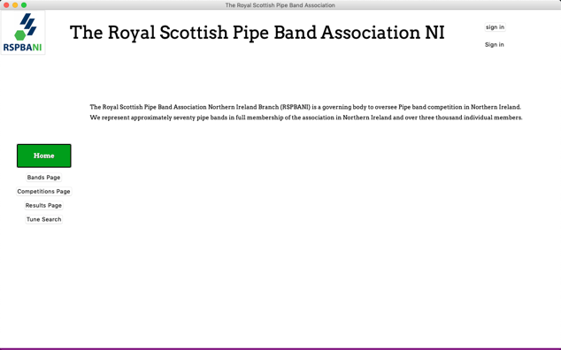**Guest View**

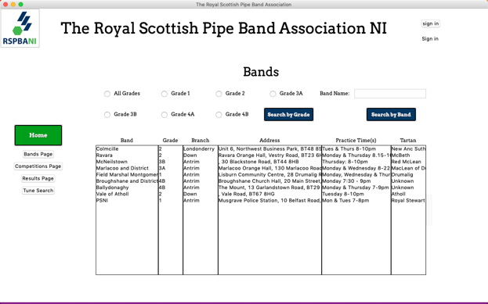This is the Home Page screen – currently it looks quite bare. I have implemented the design of one of the buttons which I will use for the rest but of which I have not designed yet. I have not been able to include the photo gallery in the prototype because I do not have the necessary skills and is not a main feature which is required by the client and is not vital to the success of the project. As I complete the rest of my coursework, I will be continually researching possible methods to my solution, so I can implement it the way the customer requires. Again, I have not will not implemented the “Latest Results” section because I have not developed the Results functionality in enough depth to successfully process this function with all the required data. I will have to pull the winning Band for each grade from the latest competition to display it on the home Screen.

The Bands page to the left shows all the Bands that are registered to the system. I have not implemented the filtering options as I unsure on how I will implement this yet and it will require a bit of research to find the most efficient way.

For my prototype, I haven’t started the functionality on the competitions or the results pages as these can only be completed once the processes relating to them are fully developed.

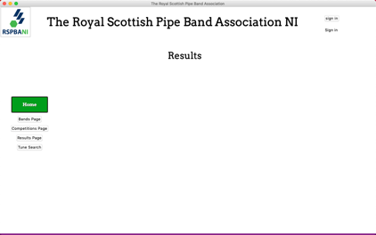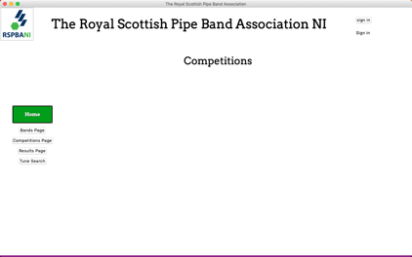

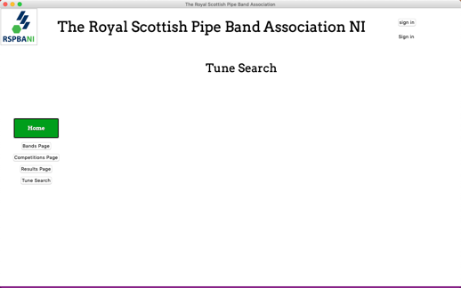I have not begun to build the Tune Search page as the functionality is very similar to the functionality, I have implemented In the Bands page. There is no point in implementing two very similar features which aren’t needed for anything else in the system.

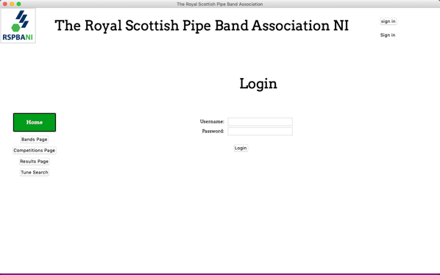**Login**

I have created my login function. This is vital for my system as different people need to access different aspects of my program. If a Band was able to access the admin features, the system would be unable and deemed as a straight failure.

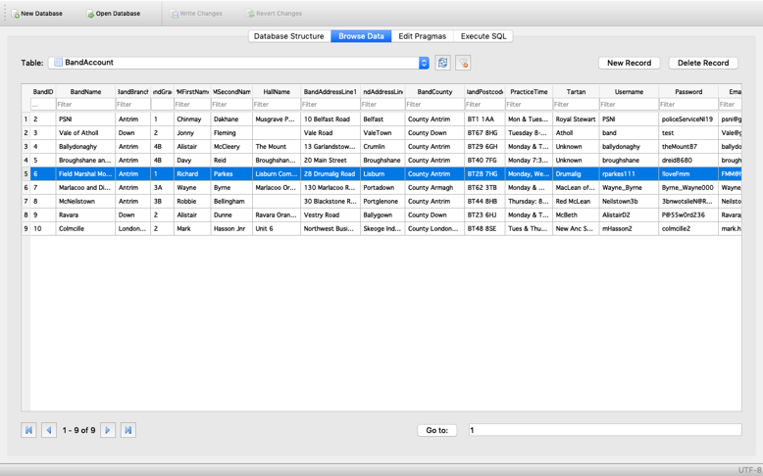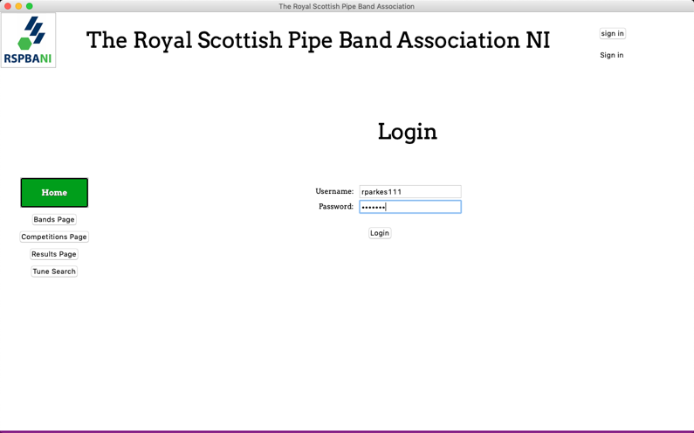

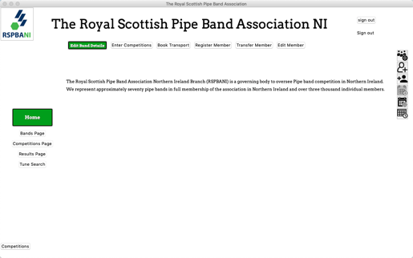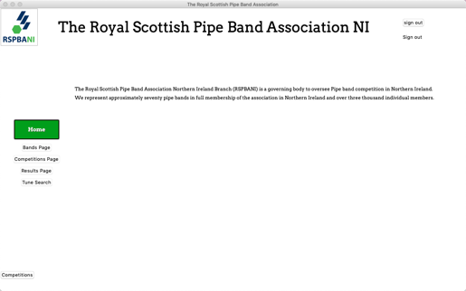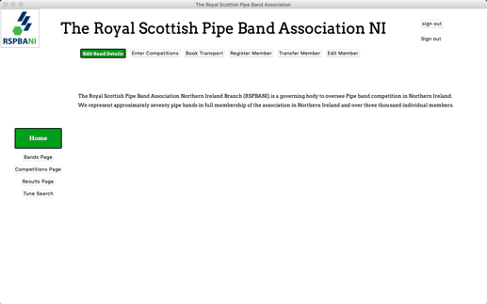Once the user has logged in successfully. They will be brought to one of these screens depending if they have signed in with certain credentials, in this case the left one for band only features.

Admin Logged in

Judge Logged in

Band Logged in

**Band Features**

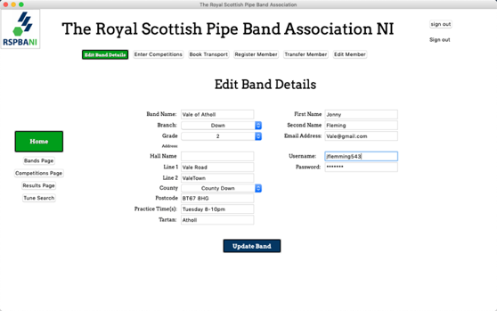Edit Band Details:

This feature allows the person logged into the band account to edit the information stored about them. The information that is currently stored about them is populated in the entry fields which allows the user to easily make the change. The message shown below will be presented to the user if the updated information is successfully stored in the database.

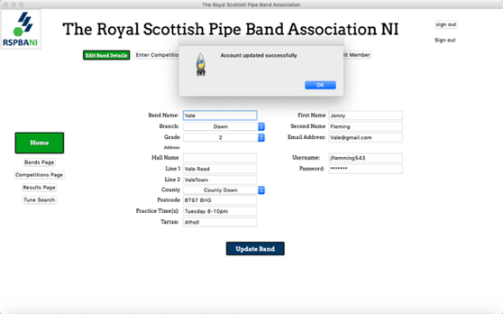

This is an example of changing the name of the band Vale of Athol to Vale and a screenshot of the database before and after the commit.



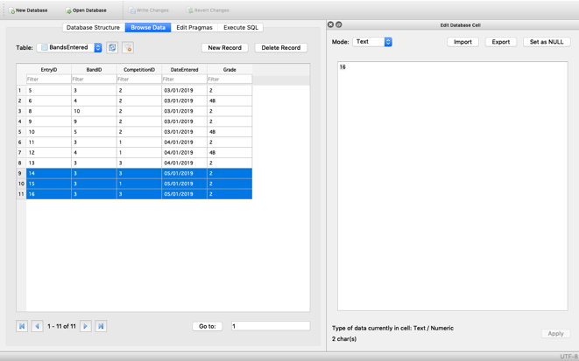Enter competitions: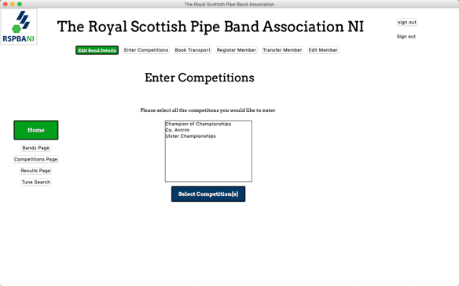

Once an admin creates a competition it will be displayed in this list. Each band is then able to select all the competitions it wishes to enter.

Book transport:

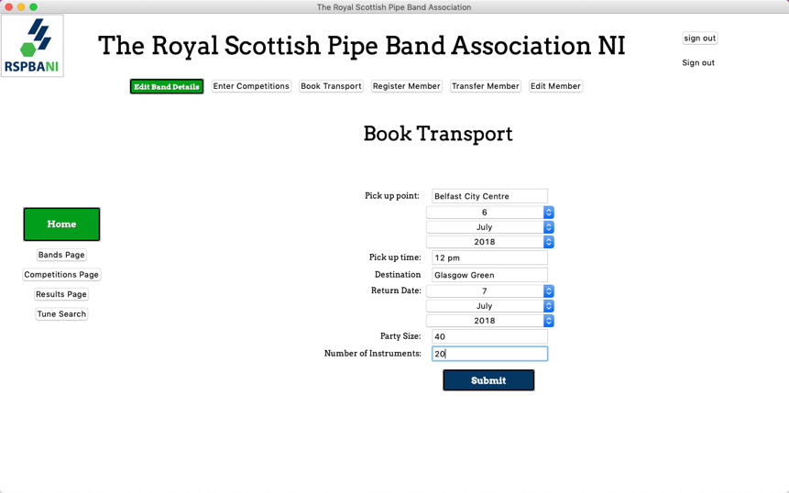The form on the right is how the band user will be able to enquire about booking transport to and or from a competition.

They must enter all the necessary details about the trip and the party.

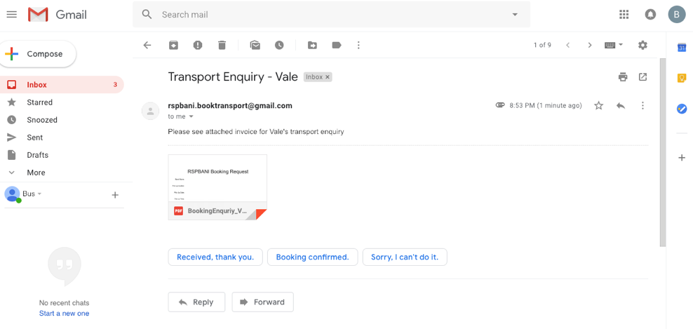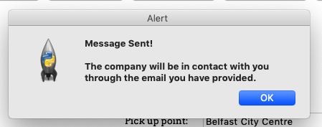When they click submit an email is sent from RSPBANI to the bus company as seen in the email below with a pdf attached with the band’s enquiry. It will contain all the fields from the booking form and also the Pipe Majors name and his email address so that the bus company can get directly in touch with the Band to confirm or get more information from them before they can confirm the booking.

I have not been able to find a good module to program the generation of the PDF document. This will come in the systems development.

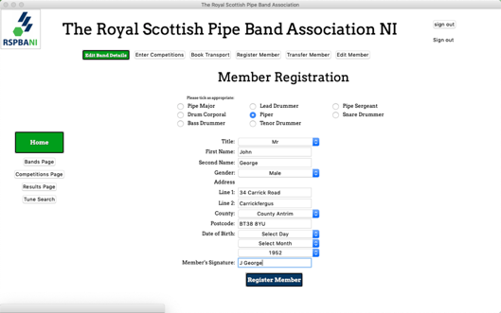Register member:

This form allows the Pipe Major to register a new member to his band which is logged in.

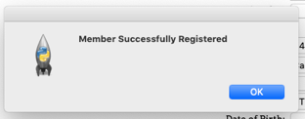The Pipe major must fill out the details of the new member and the new user must sign to confirm they wish to be registered and they allow the information to be stored about them.

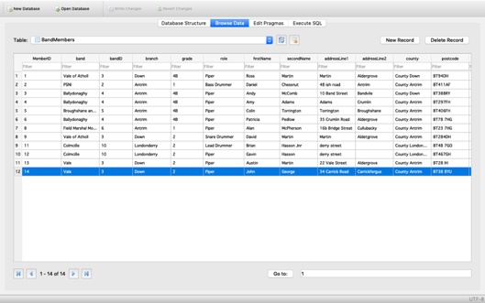The database is evidence that the new band member has been registered and their information has been stored. They are given their own identification number and they bands details to which they are registered are also stored in the same table.

Edit member:

This feature then allows the Pipe Major to edit the details of his pipe band. He must select the member he intends to edit before he is brought to a form with their current details, similar to the editing of the band’s details, where he can update their personal information. But again, the member 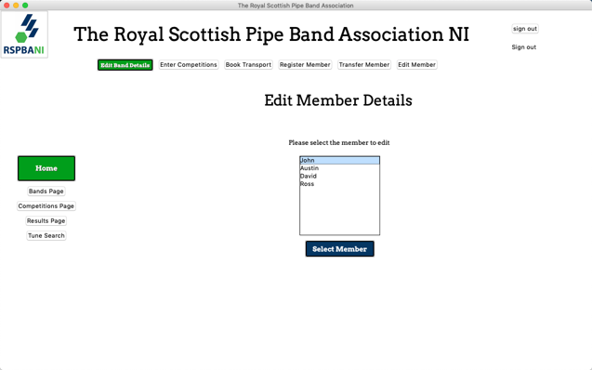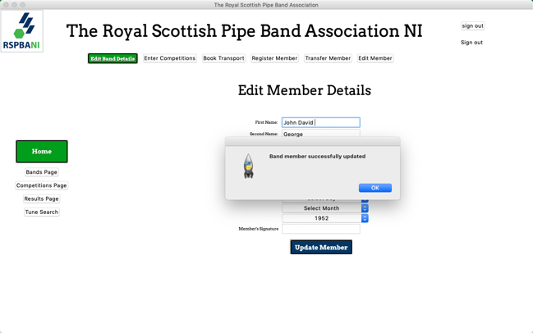must sign to confirm that they know their details have been updated.

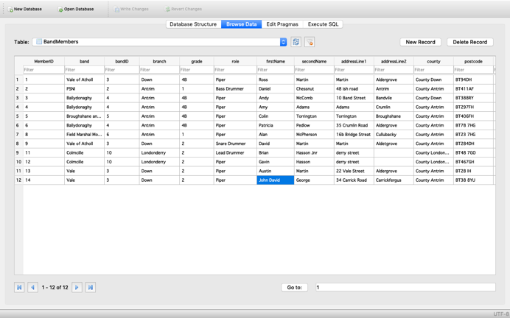

As you can see from the previous example where I register “John George”, I have now updated his name to “John David George” which have been saved to the database shown on the right.

**Admin Features**

Registering new user accounts:

Only admins will have the ability to create new user accounts. They must fill in the form for the type of user they wish to create and their username and password. I haven’t yet created the ability for when the user logs on for the first time, they will be asked to set their own password – this will come in the development.

Creating a new competition:

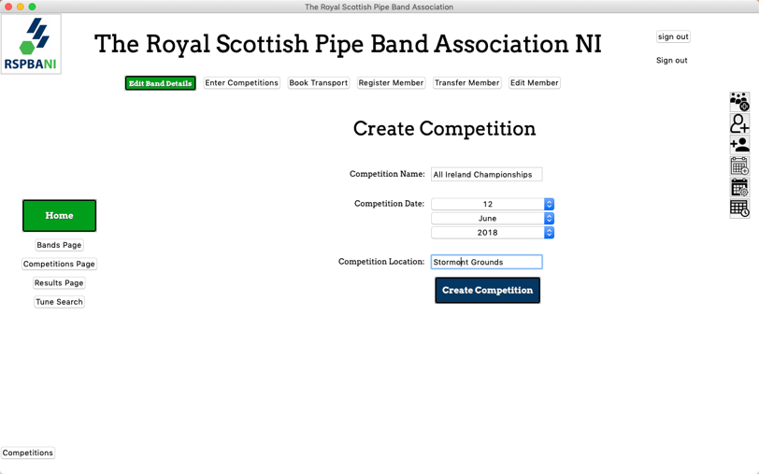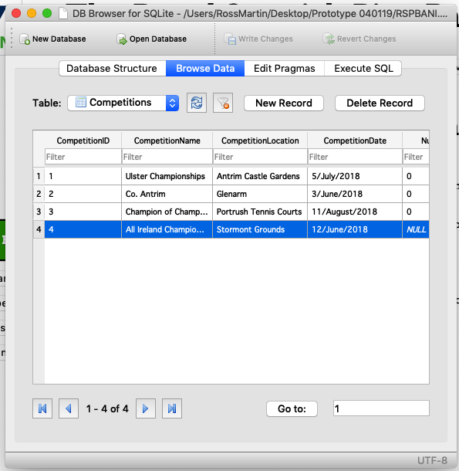Admins must have the ability to create competitions, this at the minute only has very basic functionality, which will be built upon. Once they create the competition, this will allow bands to enter it, as seen in the “Entering Competitions” in the band features section above.

Once the Admin creates the competition it is added to the Competitions table, which this example can be seen (highlighted) in the database to the right.

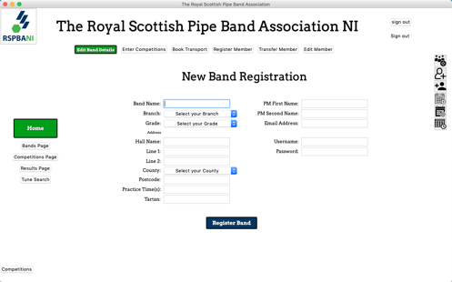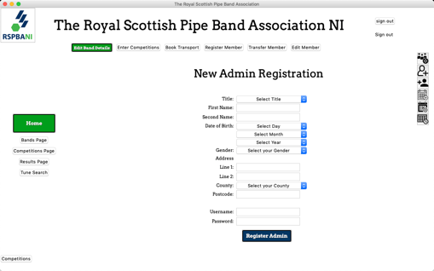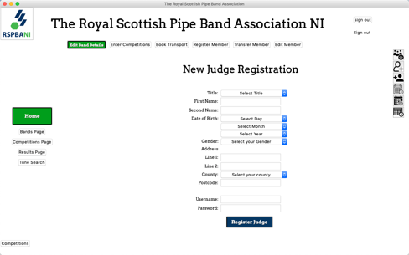Drawing competition:

Before the competition is scheduled to happen, the admins must draw the competition, this means that the bands will find out when they will be competing on the day and at which circle, they must be at given the provided time.

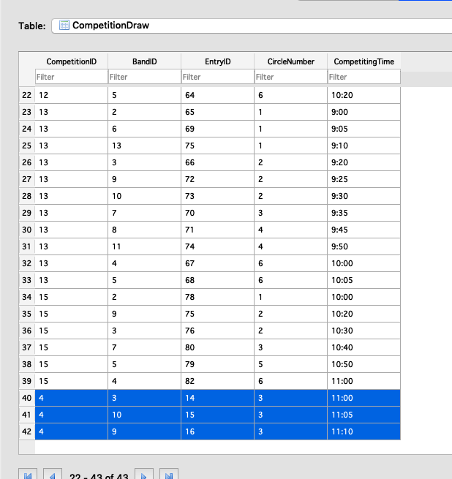

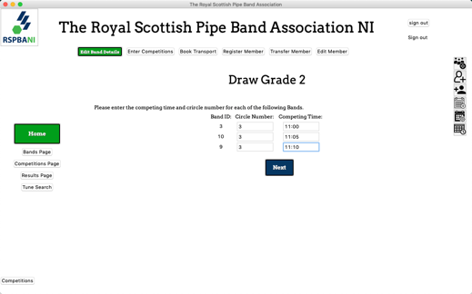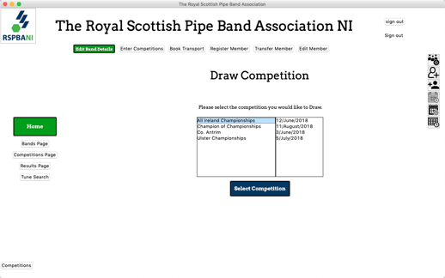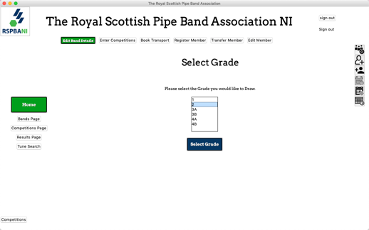The competitions draw has been updated so that all the bands that have entered the chosen competition and grade in this example (grade 2) have been added with a circle number and a competing time.

**Judge Features**

Judging a competition:

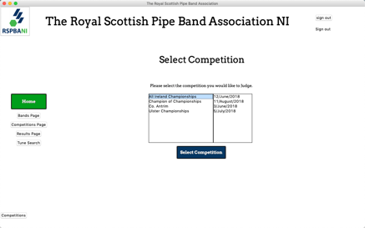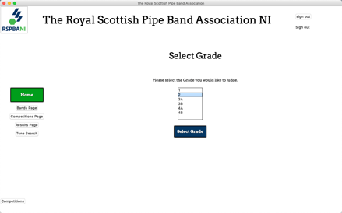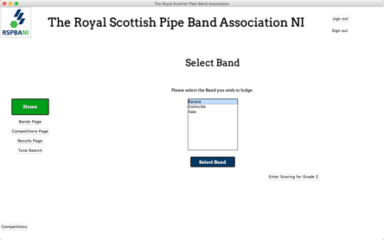After the competition has been drawn and it’s the day of the competition, the bands must be judged and ranked from best to worst. The three screens below show how the judge is able to select the competition, grade and band. On the third screen they have the option to enter their comments about each band’s performance in the grade or once all the bands have competed in the grade, they can then rank the bands form best to worst. By pressing the “enter scores for the bands” button.

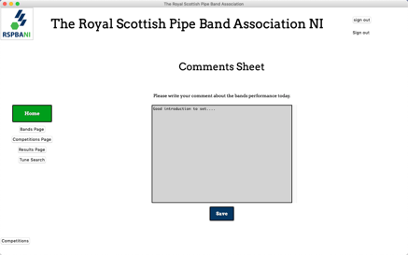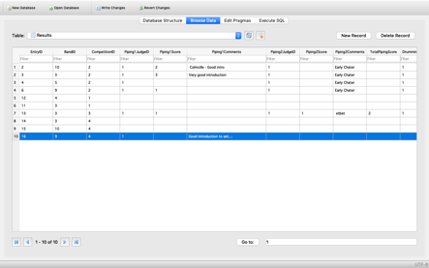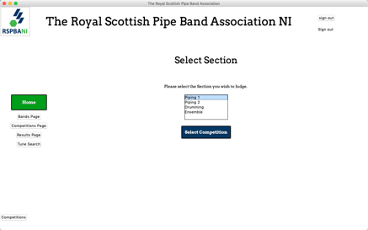If the judge selects to write their comments about the bands performance, they will be directed to the next screen where they are asked which section they would like to judge followed then by the comments sheet where they can write and update their comments. When they click save they will be brought back to the “Select Bands” page in in the previous screenshot. The database shown proves that this part of the system is functional.

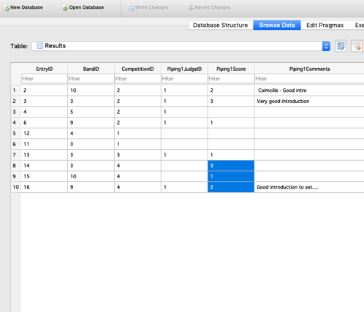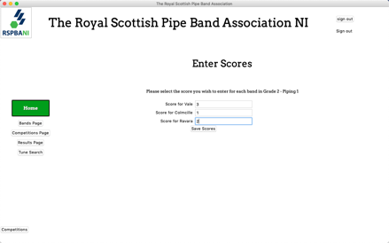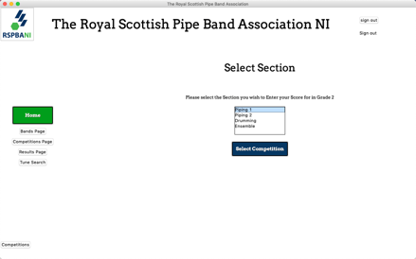Once they have commented about each band in the grade, they must select the “Enter scores for the bands” button where they can input their ranks after listening to all the competing bands. Again, the screen shot of the database shows the scores being committed to storage along with the ID of the judge who entered them.

## Evaluate the prototype solution to my objectives and describe shortcomings.

* **Guest View:**

This is the Bands page is the only page I have worked on in the guest view, simply because the guest view is a stand-alone feature available to everyone and most of the pages require information that has to be inputted and processed by the users before it can be displayed.

* + Bands Page:

The information that is being displayed in the page is correct, however I do not like the way I have developed the table using list boxes because if the information to be displayed under each heading is too long to fit in the box it is not shown properly. The way I have done this is not fit for its purpose and audience so I will be finding another way to do this.

* **Login Feature:**

I think my log in function is fit for its intended purpose. I chose to implement it the way I have because if its simplicity. Having multiple log in buttons for different users (bands, admins and judges) is not user friendly as it may be confusing for unexperienced users as they could try and log onto their account through the log in which is avoidable.

* **Admin Features:**

I am pleased with the layout of the buttons for the admin features. However, it would be impossible to distinguish between the images for the creating account feature. I will change these images so that the admin will know exactly which button to press to register for example an admin. I am pleased with the way I have been able to allow the admins to complete the functionality given to the band on behalf of the band. The simple list box before the admin is shown the same forms as the band asking to select the band which the admin wishes to edit is very effective and the best solution to solving the issue

* + Creating a band, admin or judge account:

I think the form for registering a new bands, admins or judges are sufficient as all the required fields are there and is very straight forward and accessible from everywhere once the admin has logged on. This feature functions are it should.

* + Creating competitions:

This feature is good, admins are able to enter competitions however, I think I will need to include another field that is a deadline so that bands know when they must enter by.

* + Drawing Competitions:

When it came to drawing competitions within the prototype, my solution wasn’t really meeting the objectives. The order at which the bands were given their competing time was not random and therefore in the prototype it would be very easy to “fix” the competing times of the bands. To improve this feature, I will make the bands appear randomly and will not show the band ID on the screen to admins.

* **Band Features:**
  + Editing band details

The form for editing the bands details is sufficient as it meets all objectives and is simple to navigate and is laid out in a way that it’s easy to see what you are doing. I like the way I was able to populate the entry fields with the information already stored. This makes it easy for the user to see what is already being stored and makes it easier to see what needs updated. I took this idea from my desk-based research and have been able to fully implement the functionality.

* + Registering a member:

Again, similar to the other forms I have created, I am happy with its layout and the fields I have entered, these should be all I need to include, as I have made reference to the paper-based registration form and included the same data.

* + Booking transport:

The booking transport does not fully function the way I would like it yet. I have been able to send an email to the bus company and be able to lay out the email and attach the enquiry pdf, but I have not been able to get the entered data from the fields and include them in the generated pdf. I am going to find another library within Tkinter that will allow me to design the document to a higher more professional standard. Apart from this it is working and functioning according to the objective.

* + Entering competitions:

Currently this feature is not robust enough to be a good feature. Bands have no way at telling which competitions they have entered, this can mean they can accidently enter them twice. To solve this, I will only populate the selection box with the competitions that the band have not entered already. Bands also cannot see the date of the competitions they are about to enter so I will add this like in the judge’s feature. I will need to create a deadline so that bands know when they have to enter the competitions by. Once the deadline is passed then the band will be removed from the list as they will no longer be able to enter it.

* **Judge Features:**
  + Judging of the competitions:

This feature is not perfect by any means, but it does what it is required to do. To make it easier for the judges to use, giving them less chance to make a mistake, I will change the order of the list boxes that the judge has to work their way through until they are presented with the correct comment sheet for the section they are grading.

Because each judge will be judging the same section for each band in a certain grade. I will make the judge select the section they will grade before they select the band, instead of after. This will remove the issue of the judge selecting the wrong section for the band.

I also have the issue where judges are able to select competitions for judging before they have been drawn. I will have to add an additional check to ensure only competitions that have been drawn are shown to the judges. Currently there is no validation on the scores that the judges enter. I would classify this as the most important process of the whole system. As the bands have to be ranked from best to worst, the valid data that should be entered will change depending on how many bands there are. By this I mean, if there were 7 bands entered into a particular grade. The maximum score that can be given out (to the band that was the worst) is 7. But also, the same score cannot be given to two bands. I will need to develop a method so that the entering of scores is fool proof.

**Additional shortcomings and improvements**

In addition to all mentioned above, there are a few shortcoming and improvements I will still need to make to ensure the solution is a success and is fit for its purpose. To ease all users using the system I will need to produce better refined instructional text to the user to tell them what to do at each stage of every process.

I will need to implement all of the features in the guest view. These include the photo gallery to be displayed on the home page along with the latest results summary. I need to display a list of all the competitions including all the relevant information. I will need to create a list of all the past competitions and display the full results of all competitions on the results page.

When new users log in for the first time, I will need to implement the feature where the user is asked to change their password.

I will need to validate all of my inputs to ensure that all are logical and as expected.